a lEVEL

COMPUTER SCIENCE PROJECT

Computer Game [Shadow Slash]

Contents

Analysis 2

The Problem 2

Why the program is computational? 2

Stakeholder 3

Research 3

Features 5

Limitations 5

Requirements 5

Success Criteria 5

# Analysis

## The Problem

The immersion of games. The concept is given to those who are immersed in games believing that they are within the game itself. When people play games, it allows them to leave the real world. It allows people to forget their struggles and problems. In addition, games are a fantastic way to rethink and take different approaches to real-world struggles. Why? Well because games allow people to take breaks from using their brain; it reduces stress by creating a flow of sensation and satisfaction – similar to meditation. When people are stressed, they tend to take a different perspective of the situation by changing their pace of workflow which is the main reason why I am creating a game. One way to combat stress is to use combat itself. Creating a game that is fast pace and requires the player to focus, allows the concentration to be shifted away from the stressful stimuli. But why a video game? Well, video games are engaging. Unlike taking a stroll in the park, video games allow people to completely forget about stress. Taking a stroll in the park, even though for some it relieves the pressure, for many since there is not anything for the brain to be distracted with, the brain signals out the stimuli, causing the person to be possessed with the stress. The program is going to be a 2-dimensional (2D) ‘Hack and Slash’. This is where combat is emphasized with melee-based weapons. The aim of the game is for the player to defeat waves of enemies, and reach a high score. Therefore, the main purpose of the action-packed and fast pace Hack and Slash will be for the player to be immersed in the realms of the game to mitigate stress.

## Why the program is computational?

Games heavily rely on computational methods. Without computational methods, the idea of creating a game will be so overly complex, that games, in general, will not have a place in the market. Therefore, for many games, different methods are required in order to create a successful game.

**Decomposition:**

One way in which my Hack and Slash game utilises these methods is the use of decomposition. By breaking down the functionality, I am able to make sub-functions for the sprite, actions, camera, and many other sub-layers that conclude the foundation of the final game. The main sub function is pathfinding/pathing. This is the concept of items finding the shortest route to the final destination. For that reason, the enemies are going to be using pathing to track the position of the player.

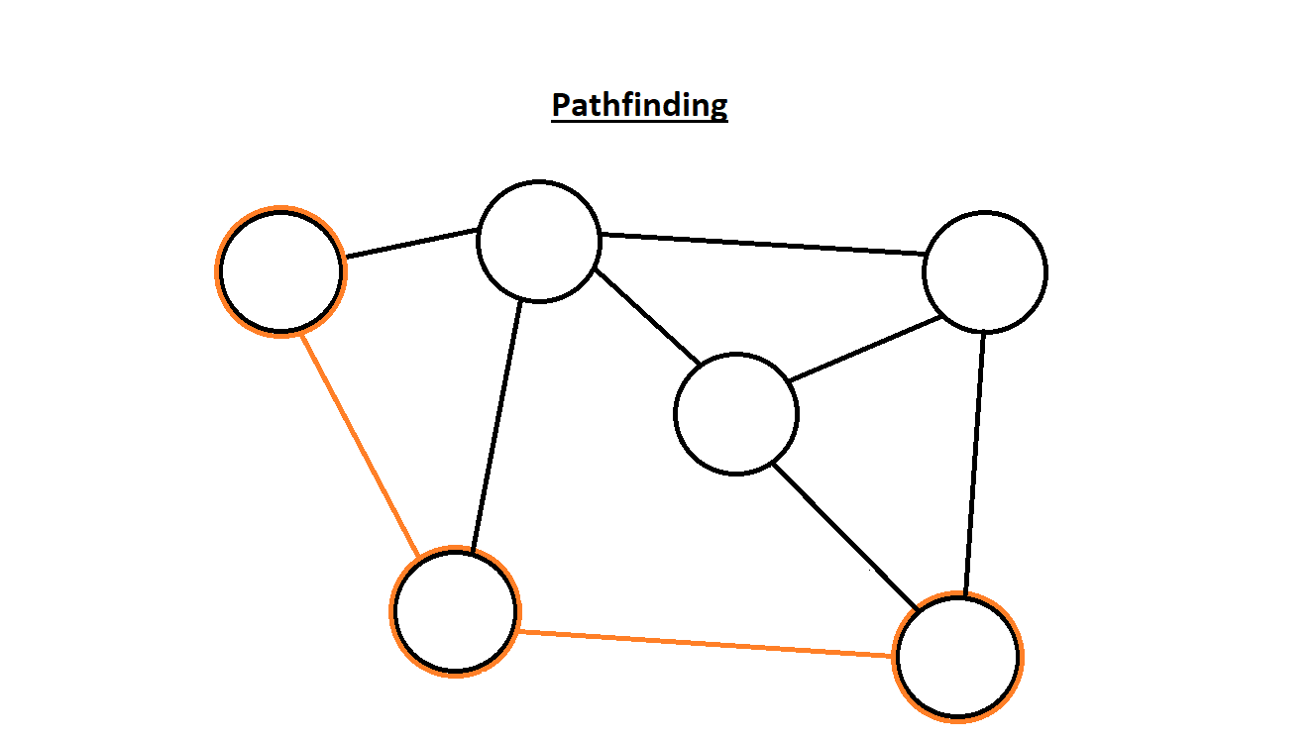

The illustration on the left tells us how pathing works. We know that pathing allows objects to follow the shortest route to their destination. Therefore, the illustration shows that the orange outlines are the fastest route to the destination compared to the other possible routes. With this in mind, I am going to be implementing a similar design for the enemy pathing.

**General Methods (Calculations):**

Furthermore, another computational method that is going to be used is calculations. Without calculations, players will be incapable of doing any basic movement. Additionally, calculations are going to be a vital implementation of the game, since it is heavily relied upon calculating the damage done and taken. The use of calculations will make the health easier to develop, the score the user receives and the movement speed

**Abstraction:**

On top of the other computational methods, the use of abstractions is going to essential for the game. Without separating ideas from reality, the game will get overly complex. The main reason is because having a complex concept of the game will cause; firstly, the programmer unable to understand what they are coding and secondly, the player unable to understand the concept of the game. Without a good vision of what the game is supposed to do in its most basic form, just the thought of playing it will become useless. By ignoring the unimportant detail and focusing of the most important parts, it will allow me to scope out the functionality and key sections of the game.

## Stakeholder

The target audience of the program is people who play games. Those who are interested in the classic hack and slash games or puzzle–action games will have the most enjoyment from the game.

## Research

### ‘Game Reference/Competition’

The Hack and Slash game, ‘Castle Crashers’ is a perfect example of what my game ideas revolve around. From the simple graphics to the smooth combat, the game is a perfect example of how many can immerse within the game and unwind. ‘Castle Crashers’ is a 2D Hack and Slash where it contains a simple story. The player has to save the princess and the king’s magic crystal. For this to happen, the player must defeat enemies with their melee-based weapon. On the image source: ‘Castle Crasher’ we can see the orange playable knight using a melee weapon and partaking in combat. This is the main concept of Hack and Slash, where the player’s goal is to defeat enemies.

|  |
| --- |
| C:\Users\16AliMo\AppData\Local\Microsoft\Windows\INetCache\Content.MSO\7F563D67.tmp (Castle Crasher) |

However, the problem lies within the engaging storyline. ‘Castle Crashers’ has a simple but addictive story. Therefore, the player will be immersed in the game for hours. As a result, they forget about their real-world tasks and deadlines and before they know it, they are stressed once again. When people want to destress, they want to take a brief period away to relax the brain. Usually, just taking 10 – 15 minutes to escape the real world is enough for someone to destress. Therefore, when the player starts playing games with storylines, they submerge themselves into more stress.

### Why Hack and Slash?

For that reason, the program is exclusively going to contain only combat.  Having combat as the core mechanic will divert the players attention away from stress. This is due to the fast pace and engaging environment. A reddit[1] user ‘ElysiX’ replied to a user ‘matushi ’questioning “Why is combat so prevalent in games? source: ‘matushi Question.’ Firstly, the question is asking why combat is increasing within games. He stated while watching E3 (Electronic Entertainment Expo), a gaming event for publishers to release new games. That for the consecutive years from 2015, around 80% of games contained combat. ‘ElysiX’ mentions source: ‘ElysiX Reply’ that combat is easy for the players mental digestion. He was implying that consuming a combat game allows a mental process that causes the clearing of a person’s stomach, reducing stress. On top of that, he mentions the use of challenge. Comparing puzzles, sports, or racing games also contains a challenge but it is the same basic idea. However, combat is thrilling as no combat is the same. From being faster than the other players/enemies to learning different control and combos to defeat enemies, all the combat is different. Combat as ‘ElysiX’ mentions is ‘mildly engaged to relax after their daily troubles.’ suggesting that combat has the power to grant people relaxation and composure. It allows someone to loosen the clouds of clustered thoughts in their head. For that reason, combat is the optimum choice when someone wants to destress.

|  |  |
| --- | --- |
| C:\Users\16AliMo\AppData\Local\Microsoft\Windows\INetCache\Content.MSO\24A26715.tmp  (matushi Question) | C:\Users\16AliMo\AppData\Local\Microsoft\Windows\INetCache\Content.MSO\F01FFF1C.tmp  (ElysiX Reply) |

In addition, it has been researched that action games in general relieve stress.

During this period, the research was done during the Covid-19[2] pandemic, this was one of the most stressful times for the entire world. One way many coped through the stressful time was through gaming. A professor at the University of Saskatchewan, Regan Mandryk[3] said that “gaming can help reduce stress and improve mental health.” They looked at people from the ages of 18 to 55 where Mandryk said that playing video games can benefit people’s emotions and mental health. They gave the example of the game ‘Fortnite’[4], where they said on source ‘Mandryk Quote’

|  |
| --- |
| C:\Users\16AliMo\AppData\Local\Microsoft\Windows\INetCache\Content.MSO\E411AD44.tmp  (Mandryk Quote) |

By going through this passage, they mention that “it allows you to escape psychologically.” This is referring to the psychological damage done to the body when stressed. Therefore, when gaming, it allows someone to forget their problems and rethink different approaches to tackle their stress. Additionally, “mastering challenges” and “have control over your environment” helps individuals overcome their stress. By breaking this down, we can see stress is a problem humans face when they have a challenge that is too difficult to comprehend. Therefore, when they play a simple combat game, it helps them feel like they have control of their surroundings. 

## Limitations

I think that the main limitation is the time constraint to create different maps, characters, and enemy designs. Pixel art is the main art style for my game. In pixel art, many individual pixels need to be coloured. In addition, the canvas size is 1280x720, and it takes a long time just for a single map to be constructed. Therefore, having multiple maps will take a long time to create, especially having uniquely comprised maps that will make my games stand out. Another issue is the character and enemy designs. Firstly, just coming up with a design for a character causes problems since I would need to think of distinctive characteristics and features that make up the character. This is because when creating and designing a character I need to think about the different components of what makes them visually appealing. After settling down with a design, I would need to create the same variation of the art, but make some small adjustments to the sprite for the different actions. Therefore, creating multiple characters and enemies will require a lot of time and effort to create them.

As I mentioned before, sprites are game assets that represent images. Each character and enemy are made from sprites. Therefore, when creating just a single character or enemy, there are going to be many sprites just for movement. This is the main reason I am making a 2D game since the only sprites that I am required to create is the left and right movement rather than up and down. Having multiple sprites does not only count for movement, it also counts for the attacks, jumping, taking damage and death. Therefore, it requires a lot of different sprites that comprise the final character/enemy. For that reason, the animation of the game is going to be hard to create due to the time needed to develop. Which is the main limitation since I lack the time required to pull off many designs.

## Requirements

### Hardware Requirements

Since this is a computer game, the main peripherals needed is a mouse and keyboard. The keyboard is required for the player to move around. While the mouse is needed to attack enemies. The internal hardware does not have to be complicated; it requires a basic GPU (Graphic Processing Unit) for the game to run as well as, having decent amount of RAM to play without poor performance and a loss of frame rates. In general, having a decent computer will allow this game to run without issues.

### Software Requirements

The user is required to install the latest version python, since the entire program is going to be running on the python language. In addition, Pygame is essential for the user to install to their computer. Pygame is a module that allows an ease of creating games such as my game. Using the same up to date operating system is also required since the game will only operate on Windows.

## Success Criteria

**Main Features**

1. Display the menu screen with ‘play’, ‘controls’ and ‘quit’ options
2. Correspond the appropriate actions with the different options
3. When ‘play’ button it pressed, it should allow the player to play the game
4. When the ‘controls’ button is pressed, it should display the controls
5. When the ‘quit’ button is pressed, it should quit the game
6. Display the map when entering the game
7. Display sprites for both player character and enemies
8. Allows the player to move left, right, jump and attack
9. Add animation for the different actions performed by player or enemy (e.g., attack, jump, death, etc)
10. A combination of different actions should not collide with each other (e.g., attack and death with)
11. Display the health bar for the player
12. Enemies should spawn at random positions
13. Reduce health of enemy or player when taking damage
14. When health reaches 0 for enemy they should die and a new one should spawn
15. When the player dies, it should display game over and return to the main menu
16. Play sound according to the action
17. Allow the user to pause displaying the ‘resume’ and ‘quit’ options

**Advanced Features (Low priority + cuttable)**

1. Having the health generate when lost after a certain time
2. Having different playable characters
3. Add different styles of enemies with unique animations
4. Having different playable maps
5. Implementing a high score function that counts scores for amount of kills
6. Represent the high score of players
7. Add special abilities (e.g., pressing the ‘E’ keys allows different moves to show)
8. Add crouching to the game as a dodging mechanic
9. Add stamina

1. https://www.reddit.com/r/truegaming/comments/9a5sy0/why_is_combat_so_prevalent_in_games/ 
2. https://en.wikipedia.org/wiki/COVID-19_pandemic
3. https://www.cbc.ca/news/canada/saskatoon/u-of-s-research-finds-video-games-can-relieve-stress-improve-mental-health-1.5563824
4. https://fortnite.fandom.com/wiki/Fortnite_Wiki